# What SQL is?

* **SQL is a standard language for storing, manipulating, and retrieving data in databases.**
* **SQL is a database language designed for the retrieval and management of data in a relational database.**
* **It helps users to access data in the RDBMS system**
* **SQL is used to communicate with the database.**

# What are the things we can do with SQL

* **SQL can execute queries against a database**
* **SQL can retrieve data from a database**
* **SQL can insert records in a database**
* **SQL can update records in a database**
* **SQL can delete records from a database**
* **SQL can create new databases**
* **SQL can create new tables in a database**
* **SQL can create stored procedures in a database**
* **SQL can create views in a database**
* **SQL can set permissions on tables, procedures, and views**

# SQL Data Types

Data types are used to represent the nature of the data that can be stored in the database table. For example, in a particular column of a table, if we want to store a string type of data then we will have to declare a string data type of this column.

## Data types mainly classified into three categories for every database.

### String Data types

Example:-

* **CHAR**
* **VARCHAR**

### Numeric Data types

Example:-

* **BIT**
* **INT**
* **DECIMAL**

### Date and time Data types

Example:-

* DATETIME
* DATE

# Types of SQL Query

## 5 types of SQL commands:

**DDL, DML, DCL, TCL, and DQL.**

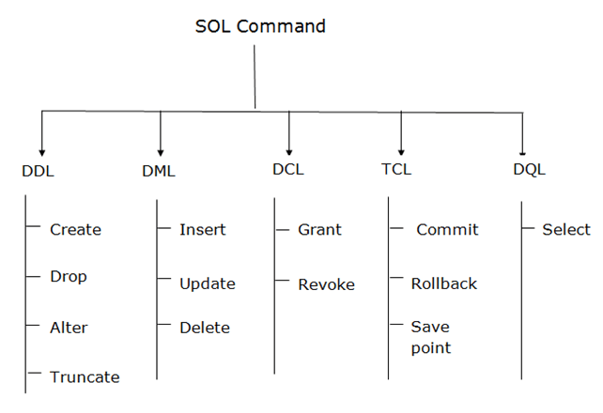

### **Data Definition Language (DDL)**

* DDL changes the structure of the table like creating a table, deleting a table, altering a table, etc.
* All the command of DDL are auto-committed that means it permanently save all the changes in the database.

a. **CREATE** It is used to create a new table in the database.

***Syntax***

CREATE TABLE **table_name** (**column_name** DATATYPES[,....]);

***Example:***

CREATE TABLE **EMPLOYEE**(Name VARCHAR2(20), Email VARCHAR2(100), DOB DATE);

**b. DROP:** It is used to delete both the structure and record stored in the table.

***Syntax***

DROP TABLE **table_name**;

***Example***

DROP TABLE EMPLOYEE;

**c. ALTER:** It is used to alter the structure of the database. This change could be either to modify the characteristics of an existing attribute or probably to add a new attribute.

***Syntax:***

***To add a new column in the table***

ALTER TABLE **table_name** ADD **column_name** COLUMN-definition;

***To modify existing column in the table:***

ALTER TABLE table_name MODIFY(column_definitions....);

***EXAMPLE***

ALTER TABLE STU_DETAILS ADD(ADDRESS VARCHAR2(20));

ALTER TABLE STU_DETAILS MODIFY (NAME VARCHAR2(20));

**d. TRUNCATE**: It is used to delete all the rows from the table and free the space containing the table.

***Syntax*:**

TRUNCATE TABLE table_name;

***Example*:**

TRUNCATE TABLE EMPLOYEE;

### **Data Manipulation Language**

DML commands are used to modify the database. It is responsible for all form of changes in the database.

The command of DML is not auto-committed that means it can't permanently save all the changes in the database. They can be rollback.

**a. INSERT:** The INSERT statement is a SQL query. It is used to insert data into the row of a table.

Syntax:

INSERT INTO TABLE_NAME

(col1, col2, col3,.... col N)

VALUES (value1, value2, value3, .... valueN);

Or

INSERT INTO TABLE_NAME

VALUES (value1, value2, value3, .... valueN);

***For example:***

INSERT INTO javatpoint (Author, Subject) VALUES ("Sonoo", "DBMS");

**b. UPDATE**: This command is used to update or modify the value of a column in the table.

Syntax:

UPDATE table_name SET [column_name1= value1,...column_nameN = valueN] [WHERE CONDITION]

***For example:***

UPDATE students

SET User_Name = 'Sonoo'

WHERE Student_Id = '3'

**c. DELETE:** It is used to remove one or more row from a table.

***Syntax:***

DELETE FROM table_name [WHERE condition];

***For example:***

DELETE FROM javatpoint

WHERE Author="Sonoo";

### **Data Control Language**

DCL commands are used to grant and take back authority from any database user.

a. **Grant**: It is used to give user access privileges to a database.

***Example***

GRANT SELECT, UPDATE ON MY_TABLE TO SOME_USER, ANOTHER_USER;

b. **Revoke**: It is used to take back permissions from the user.

***Example***

REVOKE SELECT, UPDATE ON MY_TABLE FROM USER1, USER2;

### **Transaction Control Language**

TCL commands can only use with DML commands like INSERT, DELETE and UPDATE only.

These operations are automatically committed in the database that's why they cannot be used while creating tables or dropping them.

a. **Commit**: Commit command is used to save all the transactions to the database.

***Syntax***:

COMMIT;

***Example***:

DELETE FROM CUSTOMERS

WHERE AGE = 25;

COMMIT;

b. **Rollback**: Rollback command is used to undo transactions that have not already been saved to the database.

***Syntax***:

ROLLBACK;

***Example***:

DELETE FROM CUSTOMERS

WHERE AGE = 25;

ROLLBACK;

c. **SAVEPOINT**: It is used to roll the transaction back to a certain point without rolling back the entire transaction.

***Syntax***:

SAVEPOINT SAVEPOINT_NAME;

### **Data Query Language**

DQL is used to fetch the data from the database.

It uses only one command:

a. **SELECT**: This is the same as the projection operation of relational algebra. It is used to select the attribute based on the condition described by WHERE clause.

***Syntax:***

SELECT expressions

FROM TABLES

WHERE conditions;

***For example:***

SELECT emp_name

FROM employee

WHERE age > 20;

Object oriented programming

Opps is design philosophy and it uses a different a different set of programming language.